* Cài đặt Native library
* sudo yum install apr apr-devel java-1.6.0-openjdk-devel.x86_64 openssl-devel.x86_64
* 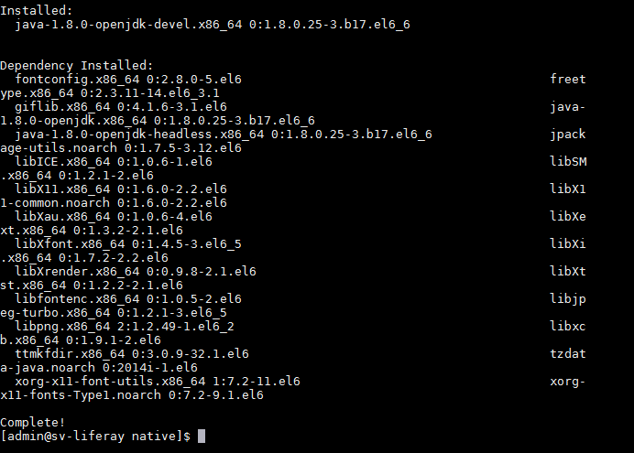
* Cài đặt trình biên dịch GCC
* sudo yum install gcc
* 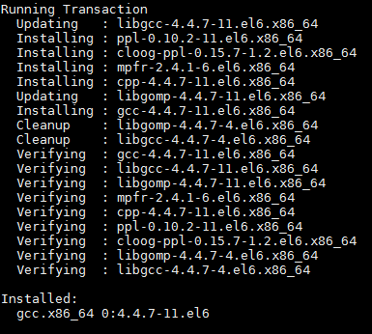
* Tải gói tomcat native tại : <http://tomcat.apache.org/native-doc/>
* Giải nén và cài đặt:
* # Extract downloaded tar
  + tar xvzf tomcat-native-1.1.22-src.tar.gz
* # Configure
  + cd tomcat-native-1.1.22-src/jni/native
  + sudo ./configure

\ --with-apr=/usr/bin/apr-1-config \

--with-java-home=/usr/lib/jvm/java-1.6.0-openjdk-1.6.0.0.x86_64 \

--with-ssl=/usr/include/openssl \

--prefix=/usr/lib64

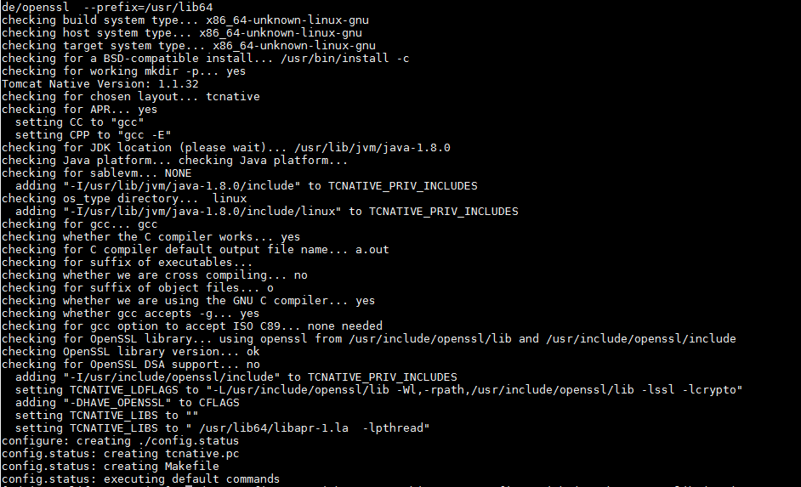

# Make

sudo make && sudo make install

Kết quả:

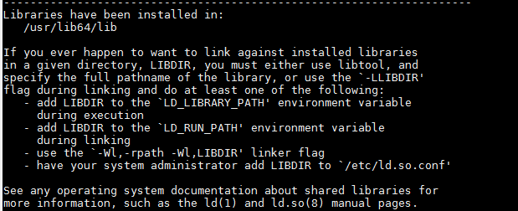

# The steps above installed the library in /usr/lib64/lib. As the default LD_LIBRARY_PATH #includes /usr/lib64, you may either change the path or set up links as shown below:

cd /usr/lib64

sudo ln -s lib/libtcnative-1.so.0.1.22 libtcnative-1.so

sudo ln -s lib/libtcnative-1.so.0.1.22 libtcnative-1.so.0